1xx - Controls | 2xx - Ground | 3xx - Flight | 4xx - A2A | 5xx - A2G | 6xx - Misc
603 – MFD Voiceattack Commands

MFD Commands

The MFD commands are context sensitive. What that means is that you must be on the correct MFD
page at the correct time to be able to use the command correctly. For example, if you say “gun range
8,000” while the TGP is on the Right MFD, really weird things will happen. Make sure you are on the
correct page.

MFD Functions: Right

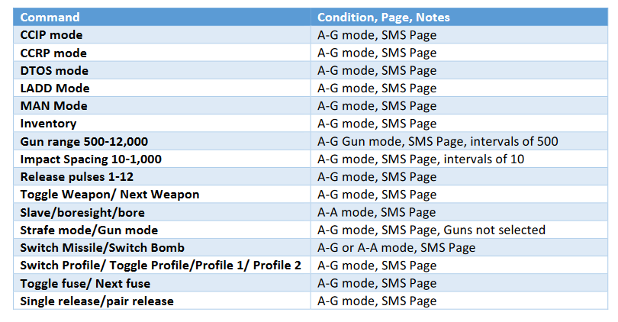
MFD Functions: Left

